FOTOS PANTALLA

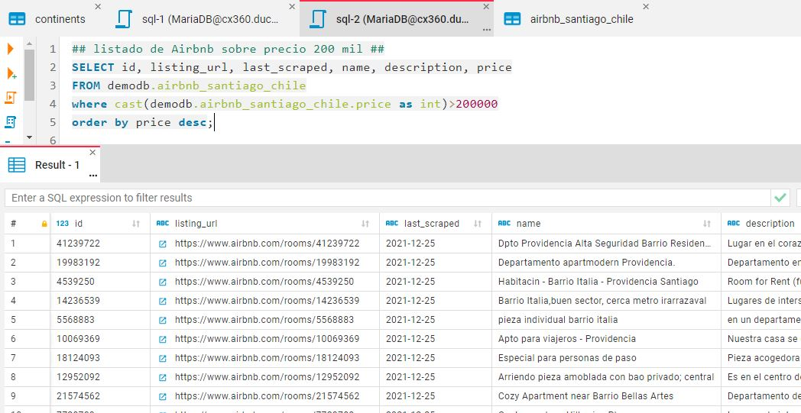

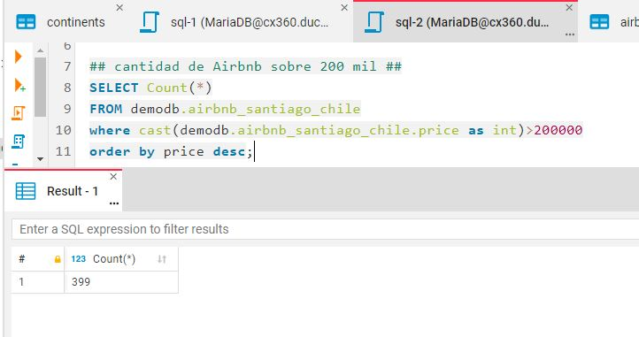

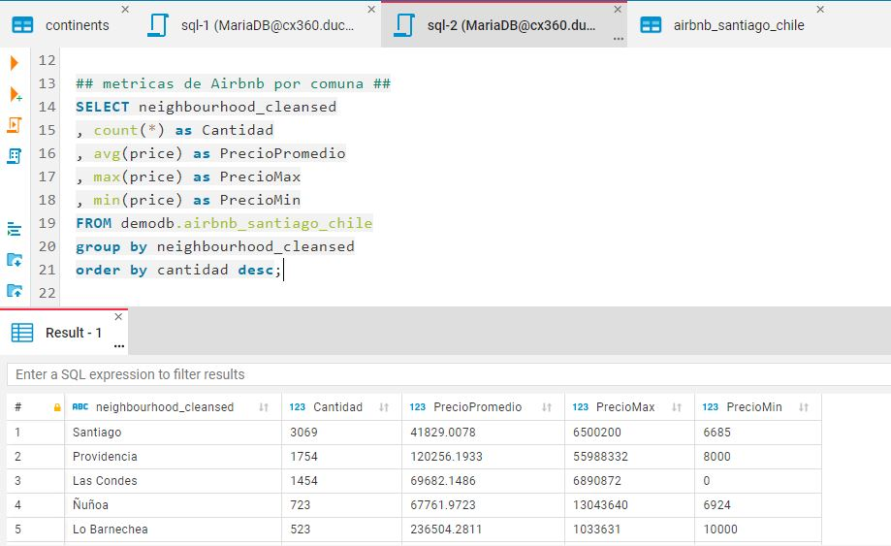

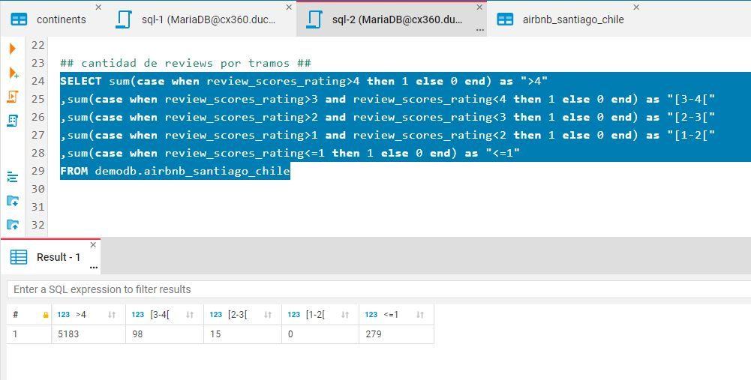

CONSULTAS:

## listado de Airbnb sobre precio 200 mil ##

SELECT id, listing_url, last_scraped, name, description, price

FROM demodb.airbnb_santiago_chile

where cast(demodb.airbnb_santiago_chile.price as int)>200000

order by price desc;

## cantidad de Airbnb sobre 200 mil ##

SELECT Count(*)

FROM demodb.airbnb_santiago_chile

where cast(demodb.airbnb_santiago_chile.price as int)>200000

order by price desc;

## metricas de Airbnb por comuna ##

SELECT neighbourhood_cleansed

, count(*) as Cantidad

, avg(price) as PrecioPromedio

, max(price) as PrecioMax

, min(price) as PrecioMin

FROM demodb.airbnb_santiago_chile

group by neighbourhood_cleansed

order by cantidad desc;

## cantidad de reviews por tramos ##

SELECT sum(case when review_scores_rating>4 then 1 else 0 end) as ">4"

,sum(case when review_scores_rating>3 and review_scores_rating<4 then 1 else 0 end) as "[3-4["

,sum(case when review_scores_rating>2 and review_scores_rating<3 then 1 else 0 end) as "[2-3["

,sum(case when review_scores_rating>1 and review_scores_rating<2 then 1 else 0 end) as "[1-2["

,sum(case when review_scores_rating<=1 then 1 else 0 end) as "<=1"

FROM demodb.airbnb_santiago_chile